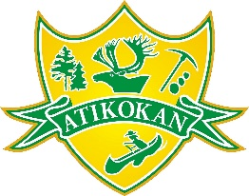
Town of Atikokan
AODA - Alternate Format Request Form

The Corporation of the Town of Atikokan is committed to providing accessible, quality services. Communications in alternate formats will be made available upon request within a reasonable time period in a mutually agreed upon format. Please complete and submit the below form or call (807) 597-1234 to submit a request.
First Name: | Last Name:
Date of Request: | Phone Number:
Address:
City: | Province:
Postal Code: | Email:
Document/Communication Support Requested:

Preferred Format:
Note: the types of alternative formats available from Town of Atikokan may include:(update list as per your organization)
- Large print
- Braille
- Email
- High contrast hard copy
- Audio
Additional Comments:

