The Corporation of the Town of Atikokan
Multi-Year Accessibility Plan
2023 - 2027

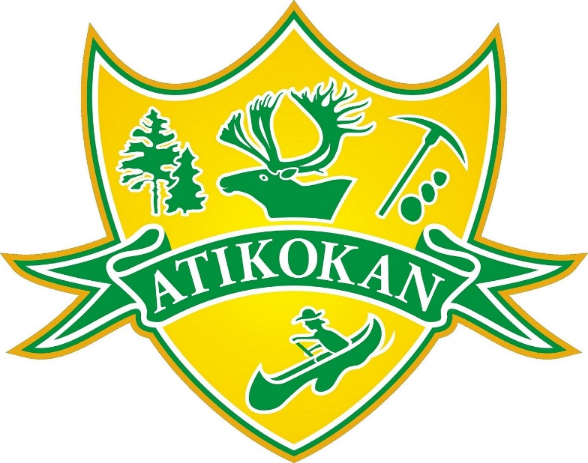

Introduction
This multi-year accessibility plan outlines the policies and actions that Town of Atikokan will put in place to improve opportunities for people with disabilities in accordance with the requirements communicated under the Integrated Accessibility Standards, Ontario Regulation 191/11.

Statement of Commitment
The Town of Atikokan believes in equal opportunity and is committed to providing a barrier-free environment that allows all people to maintain their independence and dignity. As an organization, we respect and uphold the requirements set forth under the Accessibility for Ontarians with Disabilities Act (2005) and its associated Regulations and strive to meet the needs of individuals with disabilities in a timely and effective manner.
Legislative Background

Ontarians with Disabilities Act, 2001 (ODA)
The Ontarians with Disabilities Act (ODA), was enacted in 2001. The Act requires municipalities to develop an annual accessibility plan aimed at identifying, removing and preventing barriers to accessibility.

Accessibility of Ontarians with Disabilities Act, 2005 (AODA)
The Accessibility for Ontarians with Disabilities Act (AODA) was enacted in 2005. The purpose of the Act is to develop, implement and enforce accessibility standards in order to remove barriers for Ontarians with disabilities in relation to goods, services, facilities, accommodations, employment, structures and premises.

Integrated Accessibility Standards Regulation (O. Reg. 191/11)
The IASR establishes accessibility standards and introduces requirements for:
- General requirements
- Information and Communications Standard
- Employment Standards
- Transportation Standards
- Design of Public Spaces Standards

Ontario Building Code
The Ontario Building Code outlines accessibility/barrier-free design requirements in newly constructed building and existing buildings that are to be extensively renovated. The Ontario Ministry of Municipal Affairs outlines a New Edition of the Building Code proposed in-effect date of January 2019 with proposals to include accessibility updates.

Ontario Human Rights Code
The Ontario Human Rights Code is an individual, complaints-based legislation that address discrimination. The Ontario Human Rights Code requires organizations to accommodate people with disabilities to the point of undue hardship.
Progress on the AODA/IASR

Little Falls Recreation Centre – Accessibility Upgrades
The new accessible chair lift at the Little Falls Recreation Centre has been installed and is currently operational.

Website Redevelopment
In 2022 the Town of Atikokan’s website was completely updated to be compliant with WCAG 2.0 Level AA.

Priorities and Commitments

General Requirements
- Keep accessibility standards and criteria consistent in the procurement of goods and services.
- Continue to provide training on the requirements of the IASR and on the Ontario Human Rights Code as it pertains to persons with disabilities.
- All employees, volunteers, and persons participating in the development and approval of policies will be provided with training.
- Expand mental health training offerings for all staff including e-learning.
- The Town will document and maintain a record of the training provided, including the dates that the training was provided and the number of individuals to whom it was provided.
- Training will be provided whenever changes to Accessibility Policies are made.
- Ensure all volunteers and contractors understand AODA standards when completing activities on behalf of the Town.

Information and Communications
- Conduct a regular review of the Town of Atikokan’s website content for accessibility.
- Develop guidelines and best practices for creating accessible documents and work with staff who create documents for public use to create web-ready, accessible documents at source.
- Continue to respond to feedback with respect to accessibility at the Town of Atikokan through accessible feedback processes.

Employment
- Continue to develop and document individual accommodation plans for employees with disabilities.
- Continue to ensure that employees’ individualized emergency protocols and individualized accommodation plans are reviewed on a regular basis.
- Formalize a procedure for accommodating workers with disabilities.
- Review emergency procedures on an annual basis to ensure that information is available in an accessible format or with appropriate communication supports, as soon as practicable, upon request.

Progress

An Accessibility Standards Policy has been developed with related procedures and practices developed in the following areas and are available on the Municipal website:
- Procurement of Goods, Services, Programs and Facilities
- Training
- Communication
- Customer Service
- Use of Guide Dogs and Service Animals
- Support Persons
- Notice of Temporary Disruption
- Recruitment
- Employee Supports
- Workplace Emergency Response Information
- Individual Accommodation Plans
- Transportation Standards
- Customer Service Feedback Process, including Feedback Form

Review and Monitoring

The multi-year accessibility plan will be reviewed and updated at least once every five years. An annual status report will be completed to document the progress and measures taken to implement the Town of Atikokan strategy to prevent and remove barriers and meet the requirements of the Integrated Accessibility Standards Regulation.

Feedback

We will also monitor and evaluate the feedback we have received throughout the year related to accessibility. This information may be integrated into our accessibility reports. Any comments on our accomplishments and plans are welcome and will be considered in our ongoing accessibility planning.

We welcome inquiries and feedback about accessibility and the Town of Atikokan’s efforts at meeting the Integrated Accessibility Standards Regulation.

Alternate formats of this document are available free upon request.

